2023

CSED-2026

HCI Project

11/10/2023

Observa

Table of Contents

**Team Members: (*Team 5)*** 3

**Analyzing User’s Requirements and Task Description:** 3

User Stories 3

Data Gathering 4

Surveys 4

Team Collaboration 5

Prototyping 6

Wireframing 6

UI Design 8

Iterative Testing and Feedback 11

Project Management 12

Tools Used 12

Notion with Scrum Framework 12

Figma 12

GitHub 12

Development Phases 12

First Sprint - Research 12

Minimum Viable Product (MVP) 12

Task Distribution and Epics 13

User Stories 13

Progress Tracking 13

Iterative Development 14

Collaborative Environment 14

Database Management 15

Description 15

Visual Representation 15

Request Cycle 16

Next Milestone 17

Visitor History 17

User Notifications 17

WebApplication UI 17

Optimize User Experience 17

Two-Way Communication 17

## **Team Members: (*Team 5)***

* Ahmed Mustafa Elmorsy Amer 21010189
* Ahmed Youssef Sobhy Elgoerany 21010217
* Moustafa Esam El-Sayed Amer 21011364
* Ebrahim Alaa Eldin Ebrahim 21010017
* Ahmed Ayman Ahmed Abdallah 21010048
* Ali Hassan Ali Mohamed 21010837

# **Analyzing User’s Requirements and Task Description:**

## User Stories

* + I am Abdallah, I work till late hours, so I want to view the camera when I am away, so that I can see what/who is at my door at any time.

**Tasks Included**

* + - Receive the stream on the server.
    - Stream Camera from bell app.
    - Send the stream to the front end.
    - Show the received stream to the user.
  + I am Ahmed, I want to get notified with the name of the visitor, so that I know who is at the bell without opening the camera.

**Tasks Included**

* + - Facial Recognition of visitors.
    - Database with saved visitors faces.
    - Add database to model.
    - Upload images of new visitor faces.
    - View current visitor’s name in dashboard.
    - Send notifications through the web.
  + I am Ayman, I work multiple jobs, so I am a bit forgetful. I want to change my email address and password because I forgot them.

**Tasks Included**

* + - Add settings page to edit the user info.
    - Add API requests for updating user info.
  + I am Said, I want to see who the last people who visited me are because I am sometimes busy and didn’t see who was at my door.

**Tasks Included**

* + - Add visitors page to show the known visitors history.
  + I am Mohammed, I don’t want to enter my email and password every time I login because it is repetitive and tiring.

**Tasks Included**

* + - Generate an authentication token.
    - Add remember me option.
    - Save the authentication token to a cookie.
  + I am Alaa, I want no one to be able to view my data as it invades my privacy.

**Tasks Included**

* + - Add authentication layer for each user for all requests.
    - Create login and signup pages.
    - Add login to bell app using api key.
    - Scan API key using QR code.
  + I am Mustafa, I am a 60-year-old senior. I want to have an easy way to access the camera, visitors, etc. because I am a bit tech illiterate.

**Tasks Included**

* + - Create a navigation bar for the users.
    - User-manual for the website.
  + I am Ebrahim, I am a person who gets confused and doesn't like complicated things. I want the application interface to be simple and beautiful.

**Tasks Included**

* + - Create wireframe designs for website pages.
    - Implement the pages designs with HTML, CSS, JS.
    - Implement the pages designs using VueJS.
    - Test the UI and UX of the pages.

## Data Gathering

In the process of gathering data for our ***Observa*** Smart Doorbell System project, we employed a combination of surveys and collaborative teamwork. The data collection strategy involved two primary methods:

Surveys:

We conducted surveys to systematically gather insights from potential users, aiming to understand their preferences, expectations, and specific requirements regarding home security systems. The survey responses provided valuable qualitative and quantitative data, informing the design and functionality aspects of the ***Observa*** system.

Team Collaboration

Internally, our team engaged in collaborative discussions and workshops to leverage the collective expertise and diverse perspectives within the group. Through brainstorming sessions and collaborative work, we were able to extract valuable insights, identify key challenges, and establish consensus on various design and functionality aspects of the smart doorbell system.

## Prototyping

In regard to the UI/UX design process, we first designed the wireframes, then came up with UI Design, then implemented some unfinalized front-end codes and got feedback from potential users, so we will work on the enhancements before the next milestone.

### Wireframing

The initial phase involved the creation of wireframes. Wireframes are low-fidelity, basic representations of the user interface layout and structure. They serve as a blueprint for the design, focusing on functionality and content placement without delving into visual details.

#### Log In page

The Log-in page where the user enters his e-mail and password to access his data.

#### Dashboard

The main page, where the stream is viewed, and the user gets an overview of his door-front visitors.

#### Home page

Shows a demonstration video of how to handle the stream and navigate the dashboard.

### UI Design

Building upon the wireframes, the next step was the UI design. This phase focused on adding visual elements to the wireframes, such as color schemes, typography, and imagery. The goal was to create a visually appealing and cohesive design that aligns with the brand identity and user preferences.

#### Home page

#### Peoples Page

#### Log In

#### Sign Up

#### Dashboard

#### Mobile Bell Application

* Using Flutter framework

## Iterative Testing and Feedback

The UI design needed a lot of testing and feedback from potential users, so this is not the final design, and we will conduct more surveys to fulfill all requirements that satisfy user’s experience and expectations.

# Project Management

## Tools Used

### Notion with Scrum Framework

* + Notion served as the central project management hub, leveraging the Scrum framework. Scrum principles provided a flexible and iterative approach, enabling the team to adapt to changing requirements and continuously improve the development process.
  + [Notion Workspace](https://www.notion.so/f1d360ec9d04423fb6b28705eefcbd63?v=52997229f0c7425995fa6979cea2c160)

### Figma

* + Figma played a crucial role in the UI/UX design process. It allowed the team to collaboratively create and iterate on design prototypes. Figma's cloud-based platform facilitated real-time collaboration, streamlining communication among team members involved in the design phase.
  + [Figma Workspace](https://www.figma.com/files/team/1298367844980350155)

### GitHub

* + GitHub served as the version control system for the project, enabling collaborative development. It allowed the team to manage and track changes to the codebase, facilitating seamless collaboration among front-end and back-end developers.
  + [GitHub Repository Link](https://github.com/HCI26)

# Development Phases

## First Sprint - Research

* + The project kicked off with a research sprint, focusing on understanding user needs, market trends, and technological requirements. This information guided the subsequent phases of development, ensuring a user-centric and technically feasible solution.

## Minimum Viable Product (MVP)

* + The second sprint focuses on developing the Minimum Viable Product. This involved implementing the core functionalities necessary for the system to be functional and valuable to users. The MVP approach allows for quicker delivery of a basic yet functional version for testing and validation.

### Task Distribution and Epics

* Tasks are distributed across different epics to streamline development efforts. Epics were categorized into front-end and back-end, aligning with the division of responsibilities among team members. This approach facilitated focused development and allowed team members to work efficiently within their respective domains of expertise.

### User Stories

* User stories are employed to define and communicate specific features and functionalities from the end-user's perspective. This user-centric approach ensures that development efforts are aligned with the actual needs and expectations of the target users. A screenshot of a computer

  Description automatically generated

### Progress Tracking

* Progress was tracked using a Kanban board. This visual representation allowed the team to monitor the status of tasks immediately, from "To Do" to "In Progress" and finally "Done." The Kanban board facilitated transparency and enabled quick identification of bottlenecks or areas that required additional attention.

### Iterative Development

* The use of Scrum principles, user stories, and iterative development cycles allowed the team to adapt to changing requirements and continuously improve the product. Regular sprint reviews and retrospectives ensured that the team learned from each iteration, fostering a culture of continuous improvement.

### Collaborative Environment

* The combination of tools like Notion, Figma, and GitHub contributed to a collaborative and efficient work environment. Real-time collaboration in design, version control in development, and organized project management in Notion collectively supported the team throughout the project lifecycle.

# Database Management

## Description

As shown in the diagram below, the database consists mainly of two tables one for the users signed up to the platform and the other is for their visitors. Each table has its own public key with additional one to many relationships between the Users’ dataset and Visitors’ dataset.

## Visual Representation

We use graphical interface to help us navigate the database, graphically through **pgadmin** platform.

An example is shown below of our visual representation of the dataset:

## Request Cycle

We use a graphical interface to handle the request cycle like postman.

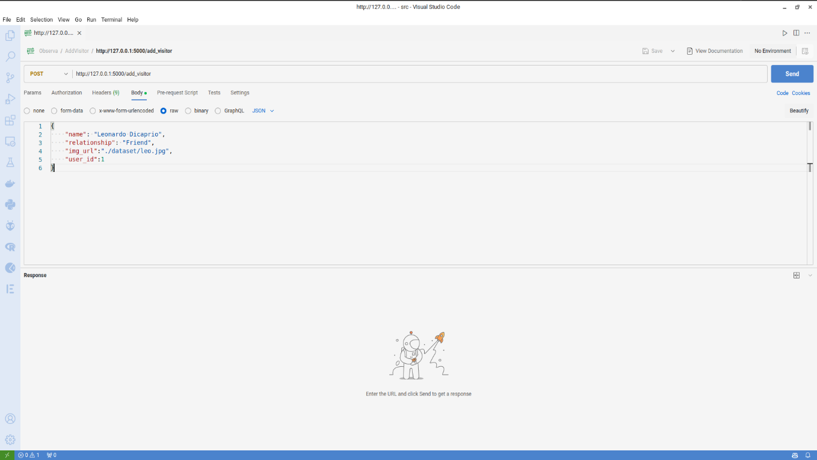

# Next Milestone

In the following phase of our smart-door bell application development, we are going to introduce some enhancement features, that improves the functionality of the project in addition to the user experience.

We will implement the following features:

## Visitor History

Users can now seamlessly review past interactions, providing an extra layer of security. The application ensures that each visit is logged and stored, allowing users to access and manage their historical data effortlessly, by storing videos and visitors’ history.

## User Notifications

The application will be enhanced with a notifications system, which notifies users and keeps them up to date with their visitors whenever someone arrives at their doorstep.

## WebApplication UI

The UI now combines aesthetics with functionality, offering users an intuitive and visually pleasing experience. The thoughtful arrangement of elements ensures easy navigation and access to the application's enhanced features, creating a seamless and enjoyable interaction.

## Optimize User Experience

Conducting interviews with potential users will take place, to benefit from their experience to optimize the user experience to what relieves them. Collecting these data will help us improving the UI.

## Two-Way Communication

Adding another layer of interactivity, the Smart Doorbell Application now features two-way communication with visitors. Users can seamlessly engage in conversations, enhancing security and convenience. This bidirectional communication capability not only serves as a deterrent for potential intruders but also facilitates smooth communication with expected visitors.